Tool Belt

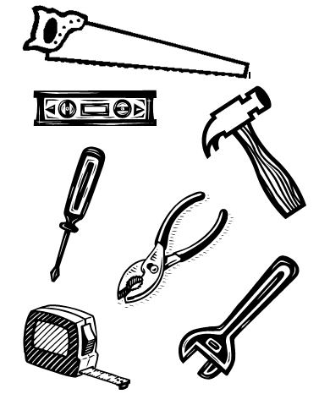
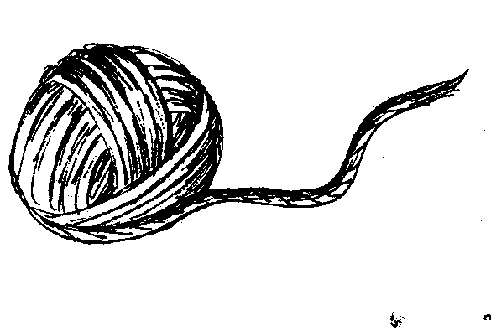
You will need:

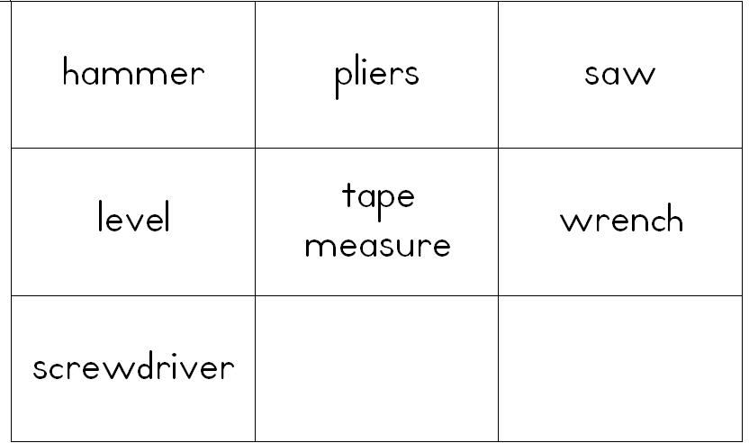
String
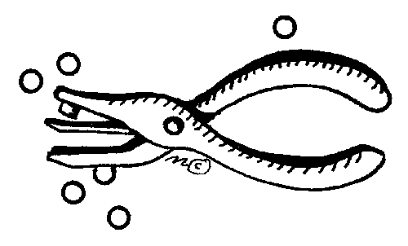

Sentence Strip
Glue
Pencil
Tools paper
Scissors
Hole Puncher
Labels

2.
1.
3.
4.
hammer
pliers
hammer

Cut out and glue the labels next to the tools.
Punch a hole in each end. Tie a piece of string in each hole to make a belt.
Glue the tools to the sentence strip.
Cut out the tools.
pliers

