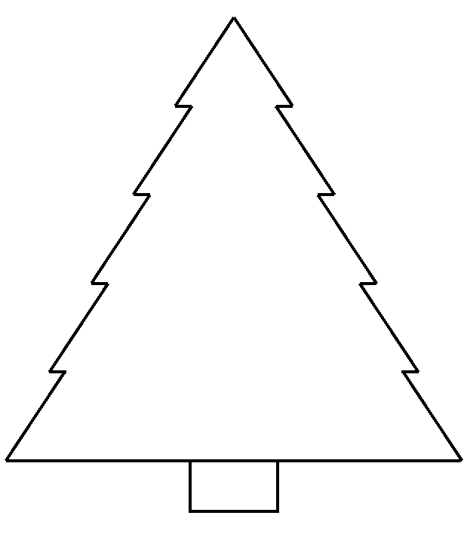
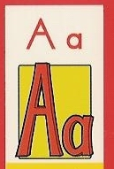
Name:
Cut
Glue
Write

